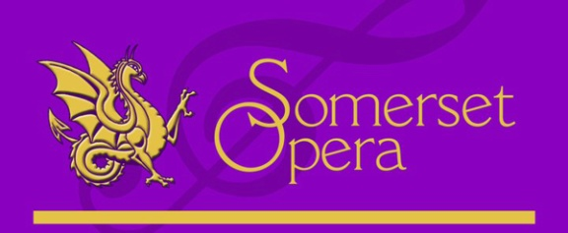
Sponsorship and advertising opportunities
Gold Sponsorship - £800
Full page advert for inside front cover or to the back cover for both spring and Summer programmes
Up to 8 tickets for Summer Show
Advert on reverse of flyers for both shows (up to 5,000 copies!)
A link from our website
Nightly Sponsorship - £250 per night (Summer show only)
Half page advert in both programmes
6 tickets for nominated night to be sponsored
A mention at the beginning of that night’s performance

Advertisements
Full page advert inside front cover or to the back cover (either spring or summer programme) £160
Full page advert inside either programme £150
Half page advert inside either programme £75
Quarter page advert inside either programme £45

Please contact: Suzi Allen
Tel: 01823 257695 mobile: 07778481859 email: suziallen@btinternet.com

